Algorithms and Programming I
LAB 11

Exercises

1- Write a recursive function that determines a number (between 1000 and 9999) is a deu number or not.


A deu number can be divided into the sum of its digits and produces another number which can also be divided into the sum of its digits.

Examples:
Input: 8748 Input: 2916 Input: 1458
Output: true Output: true Output: true

8748 / 27 = 324 2916 / 18 = 162 1458 / 18 = 81
324 / 9 = 36 162 / 9 = 18 81 / 9 = 9
36 / 9 = 4 18 / 9 = 2

2- Write a recursive function that finds the Highest Common Factor (HCF) of two positive integers is defined as


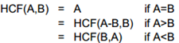

Examples:
Inputs: 12 15
Output: 3

Inputs: 30 24
Output: 6
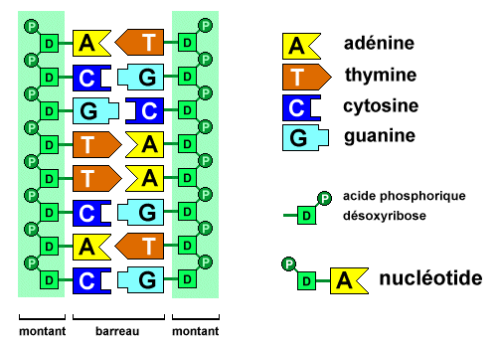

3- Write a recursive function to compute the complement of a given DNA string.
The complement of a DNA sequence is a sequence of the complementary letters (A-T, C-G) of the given sequence.

Example:
Input string: "a a a g t g c"
Output string: "t t t c a c g"

4- Write a recursive function that counts the number of even elements in an array.


Example:
Input: int[] arr = { 15, 2, 16, 17, 8, 3, 9 };
Output: 3

5- Write a recursive function that deletes all vowel characters from a given string.

Example:
Input: derya
Output: dry

6- Write a recursive program that searches a string in an existing structured array.

Note: Don’t take the values of arrays from the user. Assign them in the code.


Example:
Name (string) Age (int)
Ayşe | 18
Melek | 20
Sibel | 21
Derya | 19

Input: "sibel"; Input: "deniz";
Output: true Output: false
7- Write a recursive function that computes Liar_Liar(n).

Liar-Liar numbers are a sequence of negative numbers in which each number is two times the sum of the previous two
negative numbers. The exact formulation for the Liar-Liar sequence is:

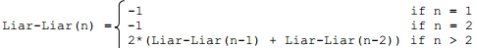

Liar-Liar( 1) = -1
Liar-Liar( 2) = -1

Liar-Liar( 3) = -4
Liar-Liar( 4) = -10
Liar-Liar( 5) = -28
Liar-Liar( 6) = -76
Liar-Liar( 7) = -208
Liar-Liar( 8) = -568
Liar-Liar( 9) = -1552
Liar-Liar(10) = -4240
Liar-Liar(11) = -11584
Liar-Liar(12) = -31648
Liar-Liar(13) = -86464
Liar-Liar(14) = -236224
Liar-Liar(15) = -645376
Liar-Liar(16) = -1763200
Liar-Liar(17) = -4817152
Liar-Liar(18) = -13160704

